**Structure of this paper**

|  |  |  |  |  |  |
| --- | --- | --- | --- | --- | --- |
| Section | Number of questions available | Number of questions to be answered | Suggested working time (minutes) | Marks available | Percentage of examination |
| Section One Multiple-choice | 30 | 30 | 40 | 30 | 30 |
| Section Two Short answer | 6 | 6 | 60 | 80 | 50 |
| Section Three Extended answer  Unit 1 | 2 | 1 | 50 | 20 | 10 |
| Unit 2 | 2 | 1 |  | 20 | 10 |
|  |  |  |  | **Total** | 100 |

**Instructions to candidates**

1. The rules for the conduct of the Western Australian examinations are detailed in the *Year 12 Information Handbook 2021*. Sitting this examination implies that you agree to abide by these rules.

2. Write your answers in this Question/Answer booklet preferably using a blue/black pen. Do not use erasable or gel pens.

3. Answer the questions according to the following instructions.

Section One: Answer all questions on the separate Multiple-choice answer sheet provided. For each question, shade the box to indicate your answer. Only use a blue or black pen to shade the boxes. Do not use erasable or gel pens. If you make a mistake, place a cross through that square, then shade your new answer. Do not erase or use correction fluid/tape. Marks will not be deducted for incorrect answers. No marks will be given if more than one answer is completed for any question.

Section Two: Write your answers in this Question/Answer booklet. Wherever possible, confine your answers to the line spaces provided.

Section Three: Consists of two parts each with two questions. You must answer one question from each part. Tick the box next to the question you are answering. Write your answers in this Question/Answer booklet.

4. You must be careful to confine your answers to the specific questions asked and to follow any instructions that are specific to a particular question.

5. Supplementary pages for planning/continuing your answers to questions are provided at the end of this Question/Answer booklet. If you use these pages to continue an answer, indicate at the original answer where the answer is continued, i.e. give the page number.

**Section One: Multiple–choice 30% (30 Marks)**

This section has **30** questions. Answer **all** questions on the separate Multiple-choice answer sheet provided. For each question, shade the box to indicate your answer. Use only a blue or black pen to shade the boxes. Do not use erasable or gel pens. If you make a mistake, place a cross through that square, then shade your new answer. Do not erase or use correction fluid/tape. Marks will not be deducted for incorrect answers. No marks will be given if more than one answer is completed for any question.

Suggested working time: 40 minutes.

1. Which of the following is not true regarding the cell cycle?
   1. The synthesis of DNA occurs during the S phase
   2. Interphase occurs over G0, G1 and G2 phase.
   3. Prophase would occur during the M phase.
   4. Daughter cells are created at the end of the M Phase

2. Which of the following procedures results in a decreased sexual desire in females?

(a) inserting a copper IUD

(b) hormonal implants

(c) tubal ligation

(d) oophorectomy

3. The following DNA base sequence is used to code for a sequence of four amino acids.

CGC ATC ATG CTA

Which of the following correctly represents the anticodons on the transfer RNA during synthesis of this string of amino acids?

* 1. GCG UAG UAC GAU
  2. CGC AUC AUG CUA
  3. CGC ATC ATG CTA
  4. GCG TAG TAC GAT

4. A researcher decided to replicate an experiment. By replicating, she hopes to increase

(a) accuracy

(b) reliability

(c) validity

(d) fairness

5. Which of the following **best** distinguishes an embryo from a zygote?

(a) An embryo is multicellular, while a zygote is a single cell.

(b) An embryo is multicellular and diploid, while a zygote is a single cell and haploid.

(c) An embryo is multicellular and haploid, while a zygote is a single cell and diploid.

(d) An embryo has fully differentiated tissues while a zygote lacks differentiated tissues.

6. Which of the following statements is correct?

(a) A gene is made up of multiple base pairs

(b) An allele contains two genes

(c) A chromosome contains only one gene

(d) A gene is made up of several chromosomes

7. A human secondary spermatocyte cell contains

(a) 4 chromosomes

(b) 23 chromosomes

(c) 46 chromosomes

(d) 92 chromosomes

8. The diagram below shows the ovarian cycle and a mature structure, labelled as X.

**X**

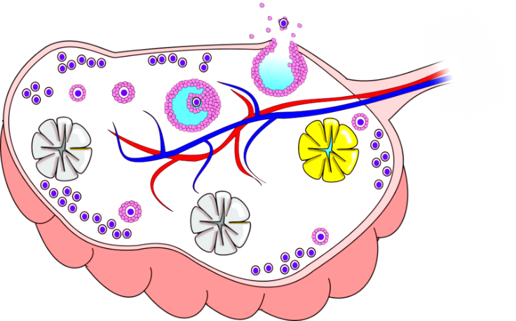

The hormone that acts on structure X is

1. Follicle stimulating hormone
2. Luteinising hormone
3. Oestrogen
4. Progesterone

9. In a mating between a man with genotype Dd and a woman with genotype dd, the expected proportion of homozygous offspring would be

(a) 25%

(b) 50%

(c) 75%

(d) 100%

10. Which of the following reproductive technologies involves depositing a mixture of male

and female gametes into the oviduct?

(a) IVF

(b) IUI

(c) GIFT

(d) ICSI

11. Which of the following foetal diagnostic tests includes the production of an

electrocardiogram?

(a) biochemical analysis

(b) amniocentesis

(c) foetal monitoring

(d) fetoscopy

12. Which of the following is a correct pathway for delivering oxygenated blood to foetal tissues?

(a) umbilical artery, ductus venosus, vena cava, right atrium, foramen ovale, left atrium, left ventricle, aorta.

(b) umbilical vein, ductus venosus, vena cava, left atrium, foramen ovale, right atrium, left ventricle, aorta.

(c) umbilical vein, ductus venosus, vena cava, right atrium, right ventricle, pulmonary artery, ductus arteriosus, aorta.

(d) umbilical artery, ductus venosus, vena cava, right atrium, right ventricle, pulmonary artery, ductus arteriosus, aorta

13. What would be the correct DNA triplet on the original DNA template that codes for the amino acid Serine (Ser)?

|  |  |
| --- | --- |
| **Amino Acid** | **Anticodon** |
| Ala | CGU |
| His | GUA |
| Ser | UCA |

1. CAU
2. CGT
3. TCA
4. GUA

14. Which type of cancer is screened using mammography?

1. Cervical
2. Bowel
3. Breast
4. Prostate

15. The following graph shows the number of male and female Chlamydia cases identified over a seven year time period.

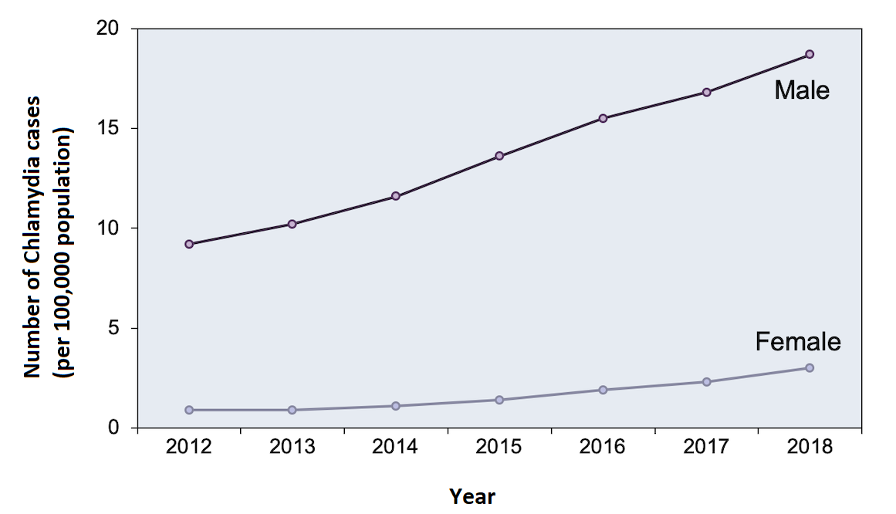

The most likely reason for the difference between the number of male and female cases is

1. males have more sexual partners than females.
2. chlamydia can be harder to identify in females.
3. males are more willing to visit the doctor to get tested.
4. females cannot get chlamydia when they are pregnant.

16. Gonorrhoea is a sexually transmitted infection that

(a) affects the mucous membranes of the urinary and genital tracts.

(b) has three main stages.

(c) can affect an embryo via the placenta.

(d) is caused by a virus.

17. The importance of DNA replication in mitosis is to ensure that when a cell divides the

(a) hereditary material will accumulate random variations.

(b) resulting daughter cells each has a full complement of DNA.

(c) chromosome number is halved equally between resulting cells.

(d) resulting cell expresses all alleles present as protein products.

18. The risk of a child developing which disease below can be minimised by increasing folic acid in the expectant mother’s diet?

(a) cleft palate

(b) spina bifida

(c) Down syndrome

(d) foetal alcohol syndrome

19. Which of the following diagrams represent monozygotic twins in a human pedigree?

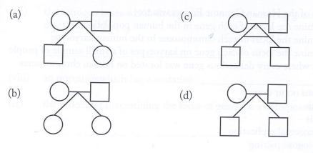

20. Gametogenesis produces

(a) 4 viable sperm cells in males, each with N chromosomes.

(b) 4 viable egg cells in females, each with N chromosomes.

(c) 2 viable sperm cells in males, each with 2N chromosomes.

(d) 1 viable egg cell in females with 2N chromosomes.

21. Which of the following methods of contraception both prevent fertilisation from occurring?

(a) the morning after pill and the condom

(b) the morning after pill and an IUD

(c) an IUD and a diaphragm

(d) a diaphragm and sterilisation

22. The hormone testosterone

(a) is produced by the seminiferous tubules.

(b) has no influence on the production of sperm in the testes.

(c) results in the secondary sex characteristics of males.

(d) is secreted by sperm as they mature.

23. In designing experiments, it is important to be aware of possible sources of error and to

minimise them as far as possible. An error that occurs due to incorrect calibration of

equipment can be classified as

(a) human error

(b) random error

(c) experimental error

(d) systematic error

24. A group of 1594 women who had been through menopause (post-menopausal) and with diagnosed osteoporosis were recruited into a research study looking at the effect of treatment with *Risedronate* over a three-year period. Women were separated into two groups; one group received a placebo (inactive) treatment and the other group received a daily dose of *Risedronate*. Both the placebo and *Risedronate* pills looked identical so the women were not aware of which medication they were taking. The women kept a diary and recorded any fractures over the 3-year period.

The results are shown below.

Cumulative fracture rates in post-menopausal women with osteoporosis when given placebo and *Risedronate* over a period of 3 years

|  |  |  |
| --- | --- | --- |
|  | Cumulative fracture rate (%) | |
| Time since taking drug (months) | Placebo group | *Risedronate* group |
| 6  12  16  22  30  36 | 2  5  7  11  13  16 | 2  3  4  6  9  10 |

A valid hypothesis for this study would be

(a) if we give post-menopausal woman who have osteoporosis *Risedronate* then they will not get fractures.

(b) *Risedronate* reduces the incidence of fractures in post-menopausal women with osteoporosis.

(c) *Risedronate* reduces the incidence of osteoporosis in post-menopausal women.

(d) post-menopausal women with osteoporosis should take *Risedronate.*

25. Which of the following variables would not need to be controlled in this experiment?

(a) all women must be menopausal

(b) all women must be the same age

(c) medication is administered daily

(d) placebo medication must be in pill form

26. An experiment is valid if it produces data that

(a) is accurate and reliable.

(b) measures what it was designed to measure.

(c) was collected consistently and reliably.

(d) is consistent with the aim of the experiment.

**Use the diagram below to answer question 27 and 28**

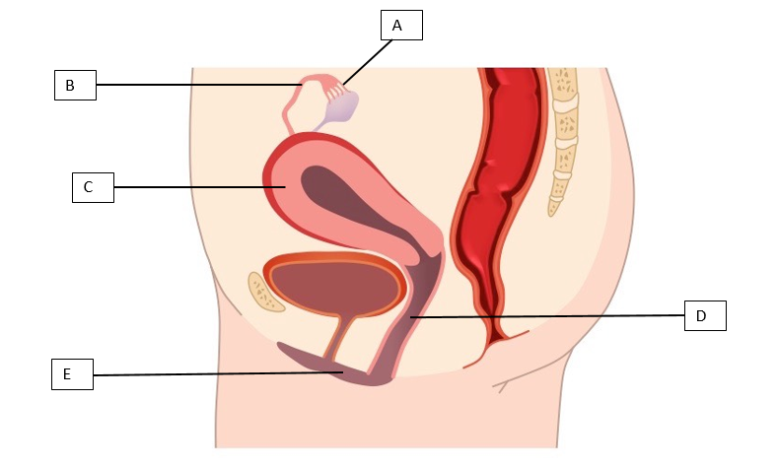

27. Identify structure E

(a) cervix

(b) vagina

(c) vulva

(d) clitoris

28. The function of structure A is to

(a) produces a female gamete

(b) carry the egg towards the uterus

(c) direct the egg into the uterine tube

(d) contains erective tissue

29. Oestrogen and progesterone are hormones secreted by the ovaries. Oestrogen causes the repair and growth of the uterine lining while progesterone maintains the lining and causes further thickening. During which phases of the menstrual cycle would the levels of oestrogen and progesterone increase?

|  |  |  |
| --- | --- | --- |
|  | **Oestrogen** | **Progesterone** |
| (a) | days 5 to 15 | days 15 to 25 |
| (b) | days 15 to 25 | days 5 to 15 |
| (c) | days 1 to 5 | days 5 to 10 |
| (d) | days 5 to 10 | days 1 to 5 |

30. The ectoderm layer develops into several body systems and organs in an embryo. This includes the

(a) reproductive system.

(b) nervous system.

(c) skeletal system.

(d) skeletal muscles.

**End of Section One**

**THIS PAGE HAS BEEN LEFT BLANK INTENTIONALLY**

**Section Two: Short answer 50% (80 Marks)**

This section has **seven** questions. Answer **all** questions. Write your answers in the spaces provided.

Supplementary pages for planning/continuing your answers to questions are provided at the end of this Question/Answer booklet. If you use these pages to continue an answer, indicate at the original answer where the answer is continued, i.e. give the page number.

Suggested working time: 60 minutes.

**Question 31 (12 marks)**

The diagram below shows the process of protein synthesis occurring within a cell.

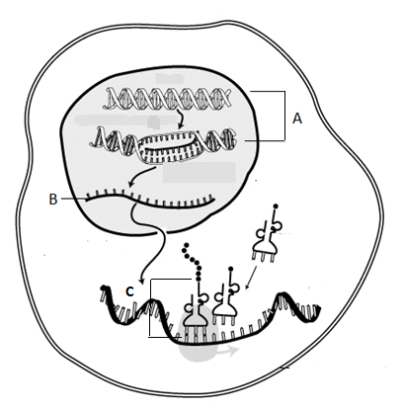

(a) Identify (3 marks)

(i) Process A

(ii) Structure B

(iii) Process C

(b) Explain the role of the nucleus in protein synthesis. (3 marks)

Mitosis and meiosis are two types of cell division that share some similarities but they are different in so many ways.

(c) Using a table, compare and contrast mitosis and meiosis.

(6 marks)

|  |  |  |
| --- | --- | --- |
| **Contrast** | **Mitosis** | **Meiosis** |
| **1** |  |  |
| **2** |  |  |
| **3** |  |  |
| **4** |  |  |
| **Compare** | | |
| **1** |  | |
| **2** |  | |

**Question 32 (12 marks)**

The diagram below shows the male reproductive system.

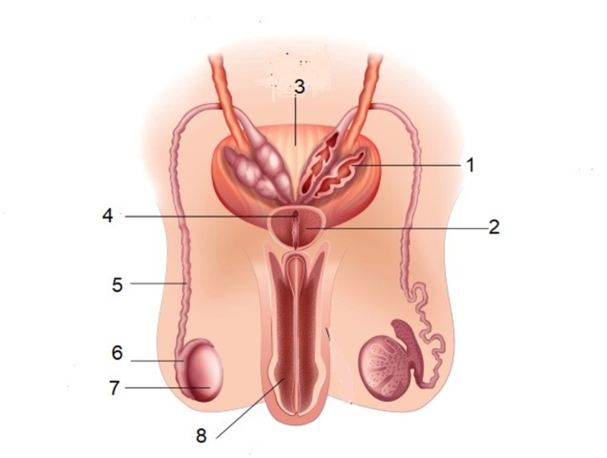

(a) Name the following structures: (2 marks)

|  |  |
| --- | --- |
| **Number** | **Structure name** |
| 5 |  |
| 6 |  |

(b) Structures 1 and 2 are known as accessory glands. State the effect of the secretions from each gland on the sperm. (2 marks)

|  |  |
| --- | --- |
| **Gland** | **Function of structure** |
| Structure 1 |  |
| Structure 2 |  |

(c) The first stage of the fertilisation of an oocyte by a single spermatozoan involves the acrosome. Describe the role of the acrosome during the first stage of fertilisation.

(3 marks)

In women the menstrual cycle is controlled by hormones secreted from the pituitary gland and the ovary. The chart below lists **some** of the events that occur during the menstrual cycle. They are not in the correct order.

|  |  |
| --- | --- |
| **Stage** | **Event** |
| A | Ovulation occurs |
| B | Oestrogen stimulates growth of the endometrium |
| C | FSH secreted by pituitary gland |

(d) List the above mentioned stages in the correct sequence.

(3 marks)

|  |  |  |
| --- | --- | --- |
|  |  |  |

(e) Lactational amenorrhoea (LAM) is the temporary infertility that follows the birth of a

Child, while the mother is breastfeeding. Describe how LAM can be used as a form of contraception. (2 marks)

**Question 33 (16 marks)**

To study the effect of HIV viral load on the average count of leucocytes found within human blood, medical researchers studied six groups of 20 HIV patients in each group, with different viral loads. Number of leucocytes was counted and averaged from each group. The results are shown below.

|  |  |
| --- | --- |
| **Viral load(HIV/mL blood)** | **Average concentration of leucocytes (cells/1µL of blood)** |
| 10000 | 200 |
| 20000 | 150 |
| 40000 | 120 |
| 80000 | 80 |
| 100000 | 50 |
| 120000 | 30 |

(a) Identify the dependent variable in the information shown above. (1 mark)

(b) Propose a hypothesis for this study. (2 marks)

((c) Graph the results from the table above onto the grid provided. (5 marks)

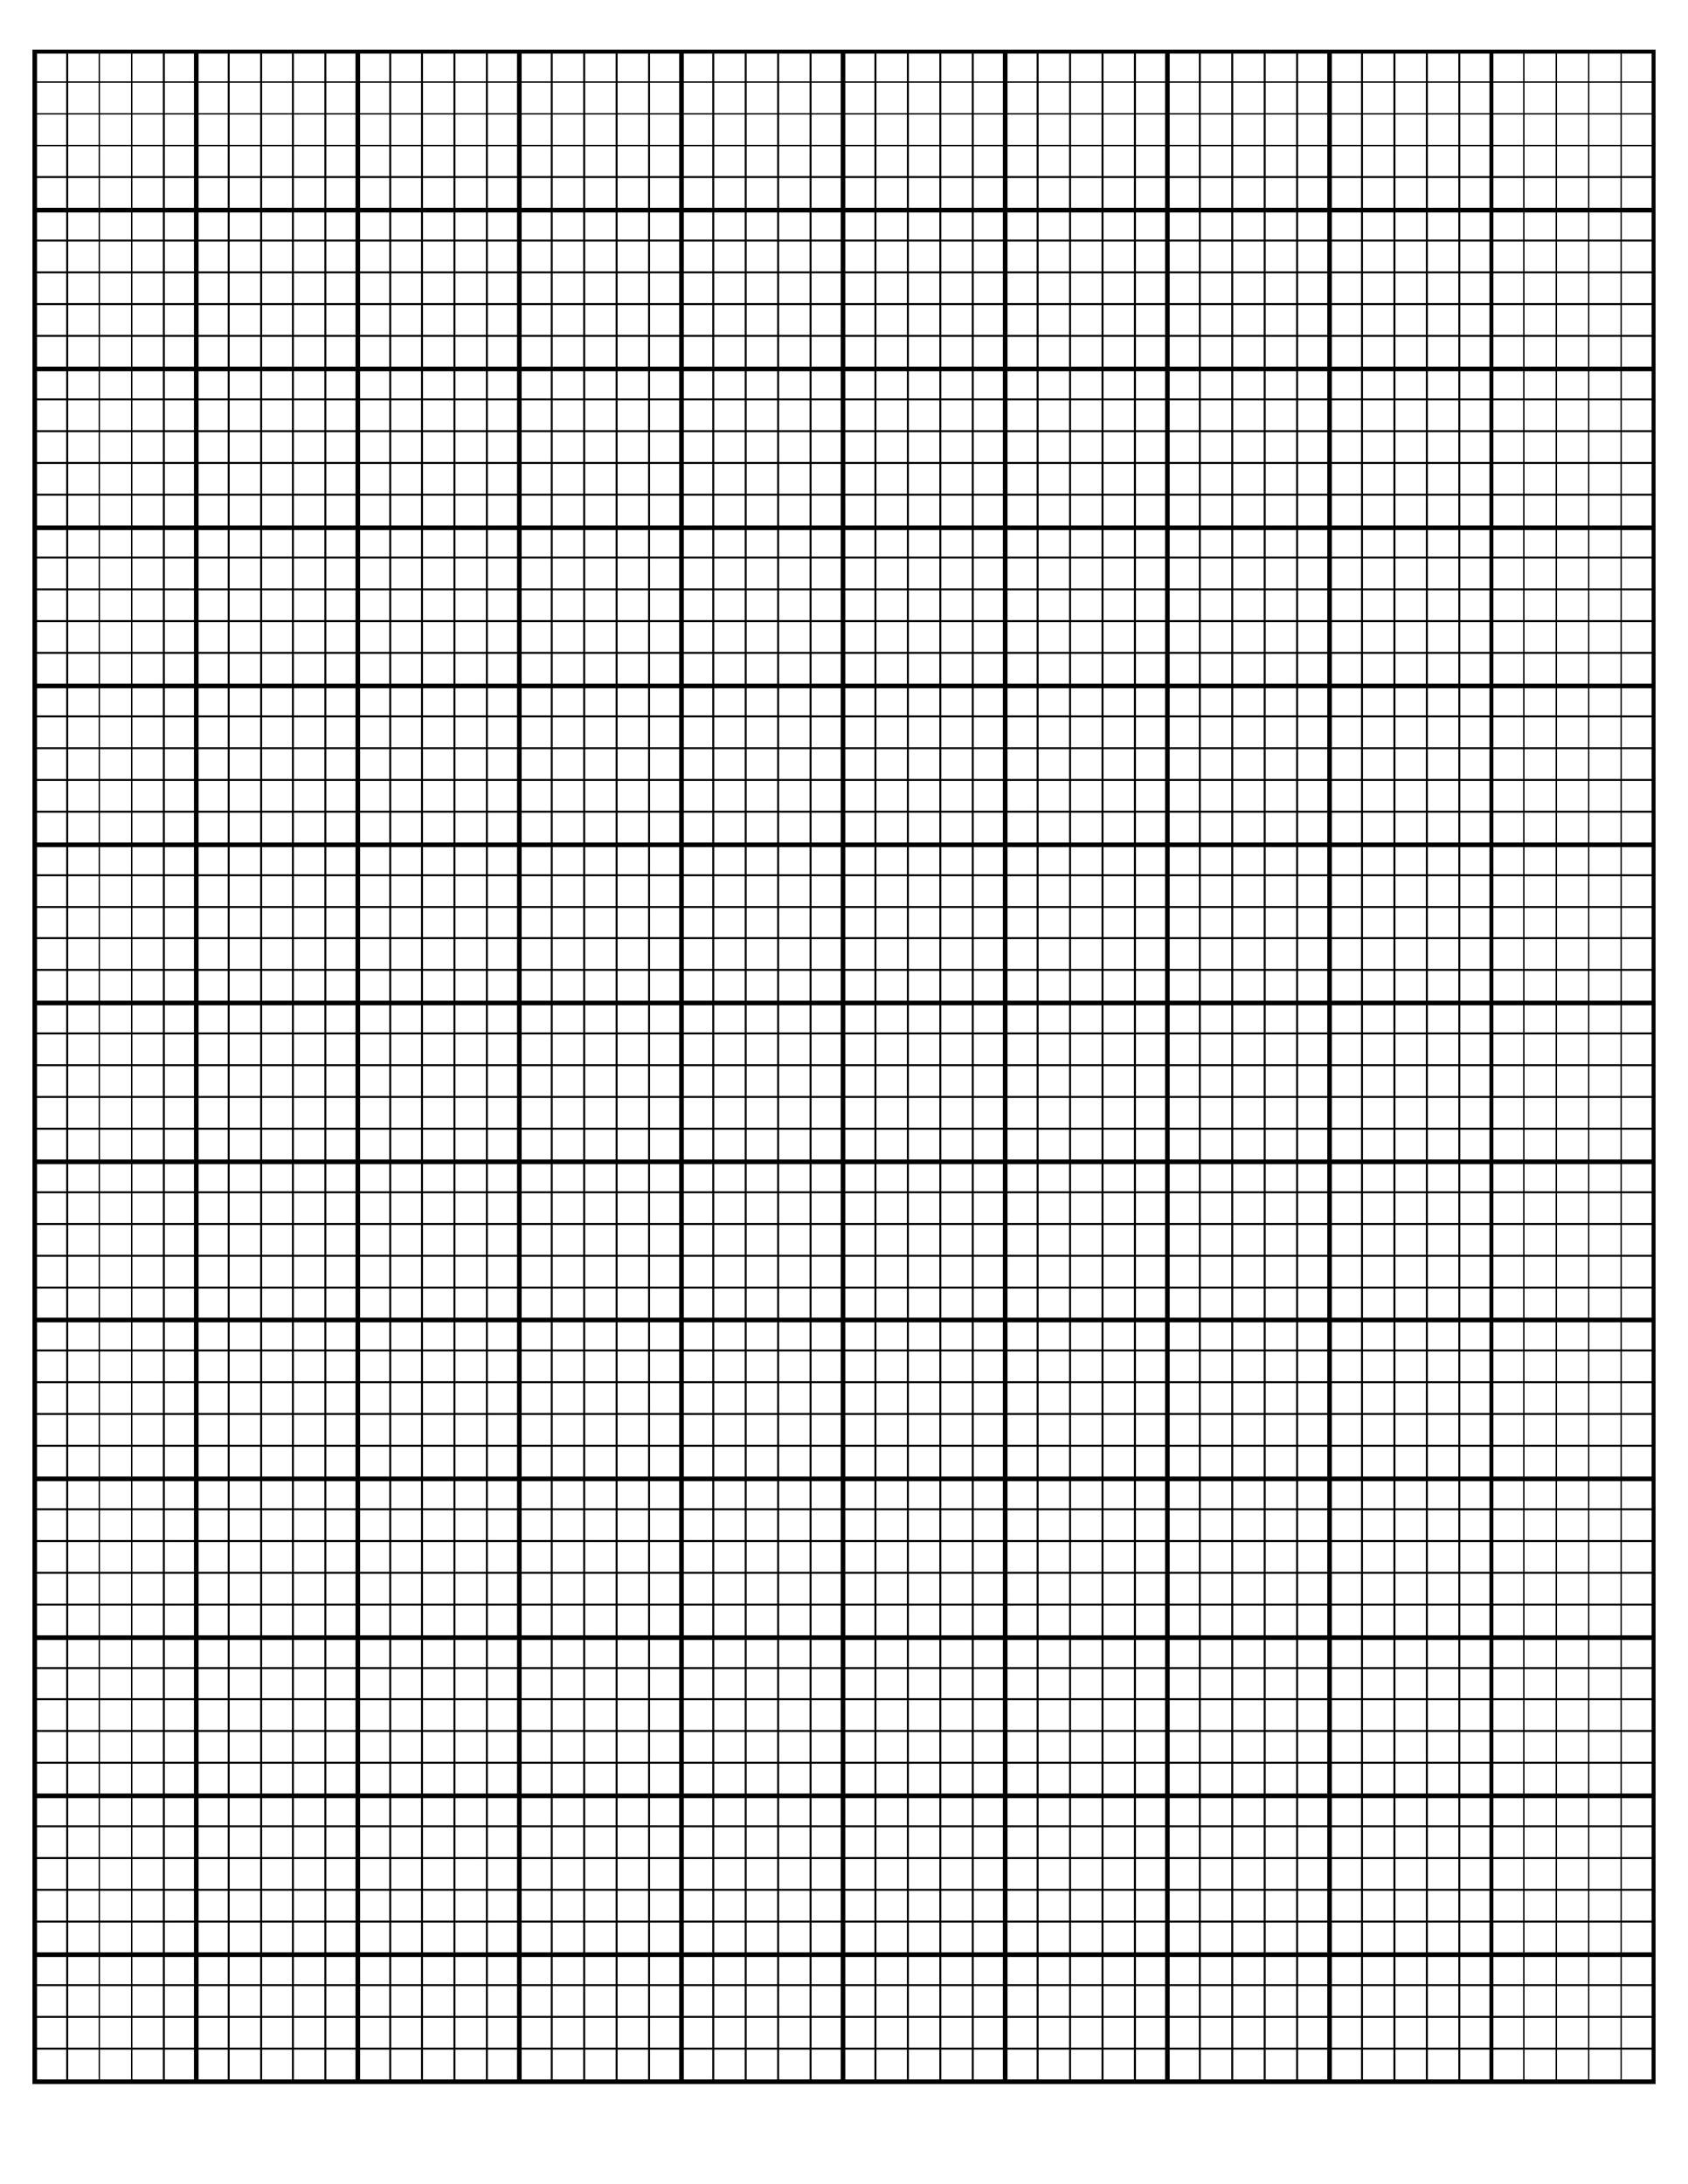

A spare grid is provided at the end of this Question/Answer Booklet. If you need to use it, cross

out this attempt and indicate that you have redrawn it on the spare grid.

(d) Using data from your graph, describe how viral load affects leucocyte concentration in blood. (2 marks)

(e) Patients infected with HIV, if left untreated, will progress through three stages. Briefly describe each of those stages. (3 marks)

(f) What type of leucocytes are attacked by the HIV virus? (1 mark)

(g) Describe two ways in which HIV can be transmitted. (2 marks)

**Question 34 (11 marks)**

* 1. Without representing the exact number of chromosomes in a human cell, draw a labelled, annotated diagram of a cell in anaphase I of meiosis. (7 marks)
  2. Describe what happens in the next phase of meiosis. (4 marks)

**Question 35 (17 marks)**

Blood groups in humans are an example of a phenotype that can be determined by multiple alleles.

(a) Complete the table below showing the possible genotypes for each blood group.

(4 marks)

|  |  |
| --- | --- |
| **Blood group** | **Genotypes** |
| A |  |
| B |  |
| AB |  |
| O |  |

(b) The ABO blood grouping system is an example of codominance. Define this term.

(1 mark)

(c) Mrs Smith has Type A blood, but she is not sure if she is homozygous or heterozygous. Mr Smith is completely unsure of his blood type. Their children have the following blood types: Daniel has type O blood, Michael and Nathan have type A blood, Kyla has type B blood and Oliver has type AB blood.

What are the possible genotypes of both Mr and Mrs Smith? Use a Punnett square to justify your answer. (3 marks)

(d) Haemophilia is a recessive, sex-linked disorder which causes an inability to clot when

bleeding.

Roy and Elaine Brown were married in 1986. Neither Roy nor Elaine had haemophilia. They had two daughters and then a son. Both daughters, Alicia and Candace, had normal clotting abilities and never had any children of their own. Their son, Mike, had haemophilia and married Beth, who did not have the disease. They had two children of their own, first Ethan and then Ella. Surprisingly, Ella had haemophilia, but Ethan did not.

(i) Draw the pedigree that traces the haemophilia disorder in this family. (4 marks)

(ii) Write the genotypes for: (3 marks)

Ella

Ethan

Mike

(iii) Why are males more commonly affected by X-lined recessive conditions?

(2 marks)

**Question 36 (12 marks)**

The graph below shows the change in mass of a foetus over the 40 weeks of a human pregnancy.

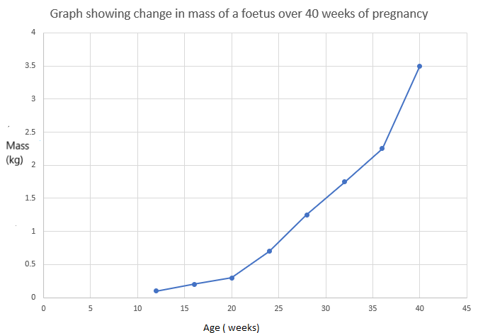

(a) Using the graph, determine the age bracket (time frame) when mass changes occur

1. the fastest (1 mark)
2. the slowest (1 mark)

(b) State the mass of the foetus at 35 weeks. (1 mark)

Lifestyle choices of a pregnant mother can impact on the development of a foetus.

(c) (i) On the graph from the previous page, sketch a line that could indicate the effect on foetal growth if a mother continued to smoke whilst pregnant. (1 mark)

(ii) Identify the condition that alcohol may have on the developing foetus

(1 mark)

The diagram below shows part of the placenta and the umbilical cord attached to a foetus.

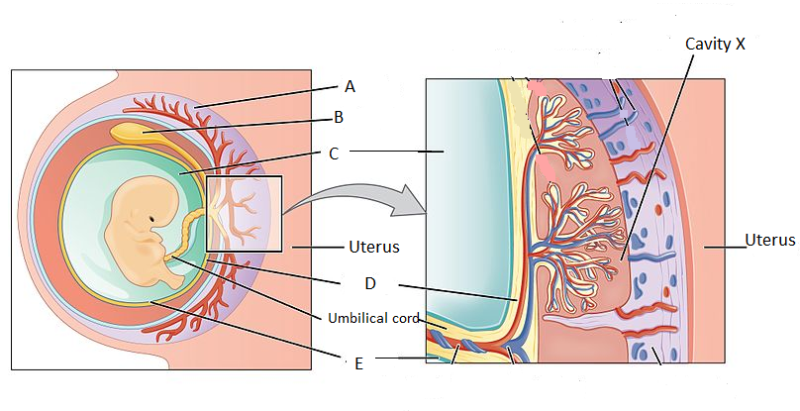

(d) (i) Name **one** substance that would be in higher concentration in the umbilical vein than in the umbilical artery. (1 mark)

(ii) Cavity X contains maternal blood. Suggest why it is advantageous to have this blood in a cavity rather than contained within a blood vessel. (2 marks)

(e) The average weight gain of a pregnant mother is 12kg. The average baby, weighs 3.5kg. Name one other change in the mother that contributes to this weight gain. (1 mark)

(f) For each of the stages of labour, identify the major change that occurs. (3 marks)

|  |  |
| --- | --- |
| Stage of labour | Major change occurring |
| 1st stage |  |
| 2nd stage |  |
| 3rd stage |  |

**End of Section Two**

**Section Three: Extended answer 20% (40 Marks)**

This section contains **three** questions. You must answer **two** questions.

Responses could include clearly labelled diagrams with explanatory notes; lists of points with linking sentences; clearly labelled tables and graphs; and annotated flow diagrams with introductory notes.

Supplementary pages for planning/continuing your answers to questions are provided at the end of this Question/Answer booklet. If you use these pages to continue an answer, indicate at the original answer where the answer is continued, i.e. give the page number.

Suggested working time: 50 minutes.

**Question 37 (20 marks)**

(a) Name **two** causes of male and **two** causes of female infertility and explain **two** ways in which infertility can be treated. Include in your explanation the name of the treatment, how the treatment is carried out and any disadvantages that might be associated with the treatment. (12 marks)

(b) Define the term epigenetics and explain how chromatin modification can affect gene expression. (8 marks)

**Question 38 (20 marks)**

(a) A pregnant woman has a family history of a rare recessive disease. She was advised

to undergo foetal genetic analysis. She was given the choice between amniocentesis

and chorionic villus sampling. She asks you for help in making the decision.

Describe how each process is carried out and provide an advantage and disadvantage

of each. (8 marks)

(b) (i) Explain how gel electrophoresis is used to produce a DNA fingerprint. (8 marks)

(ii) Describe how a DNA profile can be used to determine parentage. (4 marks)

**Question 39 (20 marks)**

1. Describe the steps in the DNA replication within a cell. (8 marks)
2. Describe in detail two (2) ways that variation can be created through the process of meiosis. (6 marks)

(c) Stem cells can be classified according to where they originate or the types of cells that

they can differentiate into. Identify and describe three different potencies of stem cells,

and provide an example of each. (6 marks)

**End of questions**

Question number: ____________________

________________________________________________________________________________________________________________________________________________________________________________________________________________________________________________________________________________________________________________

________________________________________________________________________________________________________________________________________________________________________________________________________________________________________________________________________________________________________________________________________________________________________________________________________________________________________________________________________________________________________________________________________________________________________________________________________________________________________________________________________________________________________________________________________________________________________________________________________________________________________________________________________________________________________________________________________________________________________________________________________________________________________________________________________________________________________________________________________________________________________________________________________________________________________________________________________________________________________________________________________________________________________________________________________________________

Question number:

________________________________________________________________________________________________________________________________________________________________________________________________________________________________________________________________________________________________________________

________________________________________________________________________________________________________________________________________________________________________________________________________________________________________________________________________________________________________________________________________________________________________________________________________________________________________________________________________________________________________________________________________________________________________________________________________________________________________________________________________________________________________________________________________________________________________________________________________________________________________________________________________________________________________________________________________________________________________________________________________________________________________________________________________________________________________________________________________________________________________________________________________________________________________________________________________________________________________________________________________________________________________________________________________________________

Question number:

________________________________________________________________________________________________________________________________________________________________________________________________________________________________________________________________________________________________________________

________________________________________________________________________________________________________________________________________________________________________________________________________________________________________________________________________________________________________________________________________________________________________________________________________________________________________________________________________________________________________________________________________________________________________________________________________________________________________________________________________________________________________________________________________________________________________________________________________________________________________________________________________________________________________________________________________________________________________________________________________________________________________________________________________________________________________________________________________________________________________________________________________________________________________________________________________________________________________________________________________________________________________________________________________________________

Question number:

________________________________________________________________________________________________________________________________________________________________________________________________________________________________________________________________________________________________________________

________________________________________________________________________________________________________________________________________________________________________________________________________________________________________________________________________________________________________________________________________________________________________________________________________________________________________________________________________________________________________________________________________________________________________________________________________________________________________________________________________________________________________________________________________________________________________________________________________________________________________________________________________________________________________________________________________________________________________________________________________________________________________________________________________________________________________________________________________________________________________________________________________________________________________________________________________________________________________________________________________________________________________________________________________________________

Question number:

________________________________________________________________________________________________________________________________________________________________________________________________________________________________________________________________________________________________________________

________________________________________________________________________________________________________________________________________________________________________________________________________________________________________________________________________________________________________________________________________________________________________________________________________________________________________________________________________________________________________________________________________________________________________________________________________________________________________________________________________________________________________________________________________________________________________________________________________________________________________________________________________________________________________________________________________________________________________________________________________________________________________________________________________________________________________________________________________________________________________________________________________________________________________________________________________________________________________________________________________________________________________________________________________________________



**ACKNOWLEDGEMENTS**

|  |  |
| --- | --- |
| **Section** | **Source** |
| Qu 31 | Protein synthesis  <https://en.wikipedia.org/wiki.png>  Accessed October 2020 |
| Qu 32 | Image [male reproductive system]  Credit Istock Photos by Bluering Media |
| Qu 34(a)  34(c)  Qu 36 | Image [ bones of the upper torso]  [https://en.wikipedia.org/wiki/Xiphoid_process#/media/File:Xiphoid_process_frontal.png](https://en.wikipedia.org/wiki/Xiphoid_process%23/media/File:Xiphoid_process_frontal.png)  Accessed October 2020  Myofibril diagram produced by author.  Graph produced by author |
| Qu 36 (d) | Image [Placenta]  <https://commons.wikimedia.org/wiki/File:2910_The_Placenta-02.jpg>  Accessed October 2020 |